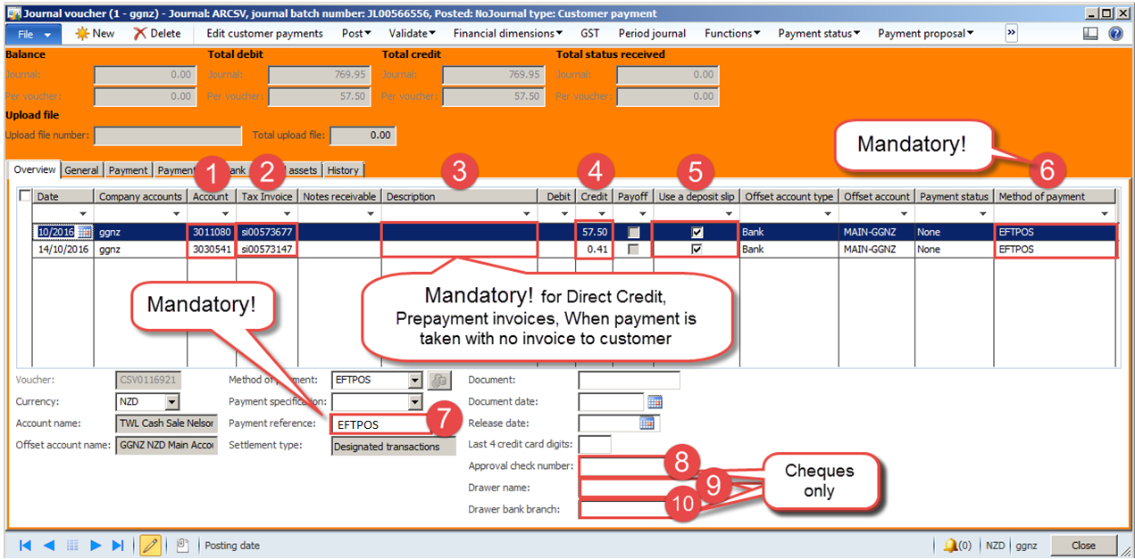**NAXT Quick tips**

**Filling in a Banking journal**

*Accounts payable > Journals > Payments > Payment journal*

1. **Account:** Customer account number
2. **Tax Invoice:**

* Enter if payment is from one invoice only (may already be populated)
* If it is for a statement payment leave field blank
* *Notify credit controller that you have taken a statement payment, and send them a copy of the remittance if you have received it.*

1. **Description:** Enter reason for payment where:

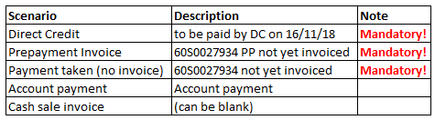

1. 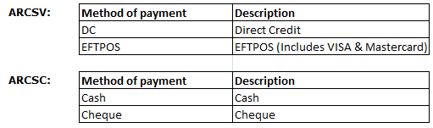**Credit:** If **Tax invoice** is entered, the amount will automatically appear, otherwise enter it manually.

* A positive **Credit** amount is payment received by Gough Group
* A negative **Credit** amount is a refund to the customer (EFTPOS only)

Make sure the **Credit** amount equals the cash received exactly.

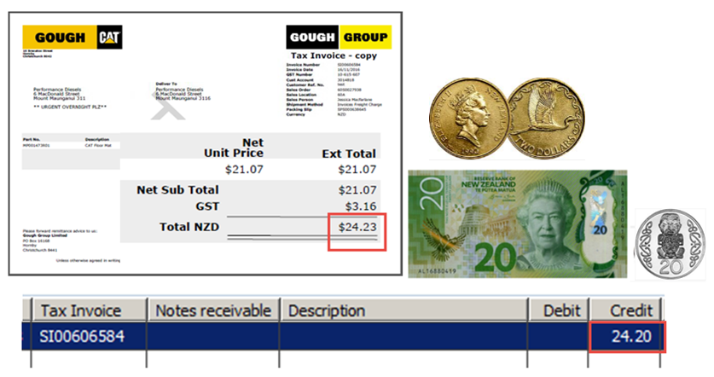

E.g.

Even if invoice says $24.23, amount should be $24.20.

1. **Use a deposit slip:** Tick the box
2. **Method of payment:** Choose from the options below. **Mandatory!**



If Method of payment is blank correction is **costly!**

1. **Payment reference:** **Mandatory!** enter payment method or sales order number e.g.

* EFTPOS
* CASH
* SO0062990

C:\Users\JESSIC~1\AppData\Local\Temp\SNAGHTMLfad9c.PNG***Cheques only****:*

1. **Approval check number**: Type in cheque number – see below

e.g. 100220

1. C:\Users\JESSIC~1\AppData\Local\Temp\SNAGHTML103024.PNGC:\Users\JESSIC~1\AppData\Local\Temp\SNAGHTML103024.PNG**Drawer name:** Type in name from cheque e.g. Douglas Adams
2. 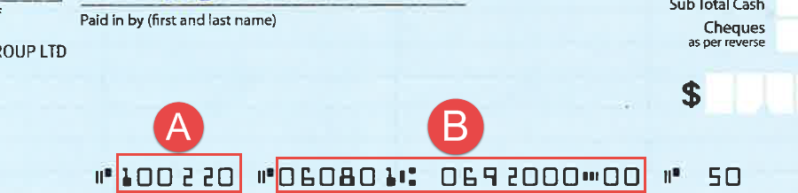**Drawer bank branch:** Type in bank and branch digits from cheque - see below

e.g. 060801069200000